* **What is NetCDF Format File?**

A NetCDF file is a format of file that usually uses in climate data. NetCDF files usually has multi-dimension that each dimension is a separate variable. NetCDF variables that contain coordinate data are referred to as coordinate variables, scalar coordinate variables, or multidimensional coordinate variables.

For example, if you want to save the rainfall data for a region in historical periods, so your data have 3 dimensions. Two dimensions depend on spatial resolution and the last dimension depends on temporal resolution. Each of these dimension is a variable into NetCDF file and has a value for each scale.

A variable may have any number of dimensions, including zero, and the dimensions must all have different names.

Your main variable in your NetCDF file is rainfall and has 3 dimensions and each dimension has been defined by a variable such as lat, lon, and time. Finally you have a NetCDF file with 4 variables:

1. Rainfall is a variable with 3 dimension.
2. lat is a variable with 1 dimension. (Variables representing latitude must always explicitly include the unit’s attribute; There is no default value.)
3. lon is a variable with 1 dimension. (Variables representing longitued must always explicitly include the unit’s attribute; There is no default value.)
4. time is a variable with 1 dimension. (Variables representing time must always explicitly include the unit’s attribute; there is no default value.)

This is a simple example of NetCDF files that was presented as following chart:

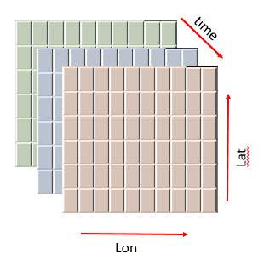

In NetCDF files each variable can have several attributes that in these attributes there is a description for that variable, e.g. units. The units attribute is required for all variables that represent dimensional quantities. For example in the time variable maybe “units: day” or “start since: 1981-1-1”. Each NetCDF file has a global attributes that represents a description about your file or producer of the file.

* **What is NetCDF Viewer?**

NetCDF Viewer can show the variables of your files and can present each variable has how many dimension. NetCDF Viewer shows to the user that how many elements are there in a dimension. With NetCDF Viewer, the user can view global attribute or attributes of each variables. NetCDF Viewer can show the data of each variables that the variable has one dimension. If your variable has more than one dimension, NetCDF Viewer can’t show it and you should use NetCDF Extractor.

With NetCDF format of file, we can save big data with different attributes and dimensions.